WEATHER EXPLORATION EXPERIENTIAL
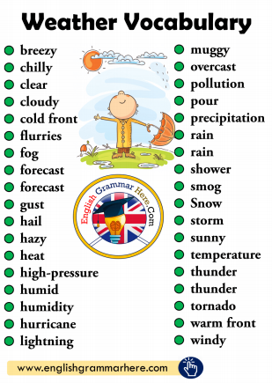
Let’s try a top-down approach!
1. Using the first piece of paper, write down
a list of words or phrases that describe
your current state in WEATHER TERMS!
WEATHER EXPLORATION EXPERIENTIAL
2. Next piece of paper, using
line/shape/color FILL the page with the
FEELING of this weather state you have
described!
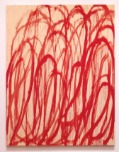
WEATHER EXPLORATION EXPERIENTIAL
3. Final step, translate this image to
movement or sound.
Explore with your body: move around the
room. How does this weather move? If you
were experiencing this weather, how would
you move through it?
Explore with sound: make rhythms and
noises, using whatever is available
or find a song/recorded music.
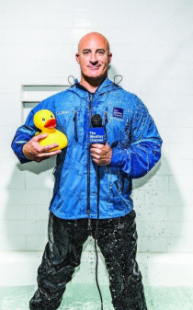
WEATHER EXPLORATION EXPERIENTIAL CONNECTING IN BREAKOUT ROOMS!
Part One: Share your individual weather states with the group! Start with part 3 [sound/movement] then share drawing or words as needed!
Part Two: GROUP FORECAST
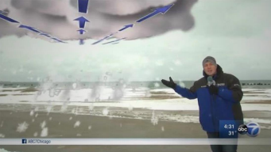
Together, create a forecast for the future
(this can be creative- does not have to be
realistic). Consider what you want/need!?
Prepare a short “skit” of a weather person
giving this forecast (think TV or Radio)!

