Think Indigenous Module #3
Resources, Methodologies, and Strategies to Support Students Through Trauma

- To support students through trauma, we must understand where their trauma stems from by focusing on the thoughts and feelings behind the behaviour.

- Empathy is a key component in supporting students through trauma. Educators must be willing and ready to address their own unresolved issues throughout the process.

TABLE OF CONTENTS
Contact Information, Supplementary Reading Resources and Websites………………3
Purpose and Module Objectives……………………………………………………………………………...........3
Assignment/Module Requirement Option #1 and Rubric…………………….…………………….4
Assignment/Module Requirement/ Option #2 and Rubric …………….…………………...…..5
Schedule …………………………………………………………………………………………………………….……………….6
ACEs Information……………………………………………………………………………………………………….….….7
Group Member Roles…………………………………………….……………………………………………………….....10
Individual Roles (Negative Social-Emotional Roles) …………………………………...………..…..11
Defense Mechanisms………………………….……………………………………………………………………………..12
ABC Method………………………………………………………………………………………………………………………..14
Active Listening and Attending Behaviour/Basic Listening Sequence…………….….…15
“3 V’s + B” ……………………………………………………….……………………………………………………………..…..19
Empathy and Anticipated Student Responses…………………………………………………………….21
Postmodern Approach in Supporting Students Through Trauma……………………….….22
Karpman Drama Triangle……………………………………………………………………………………………......23
Effective Practice for Teachers and Indigenizing Trauma Informed Responsiveness…………………………………………………………………………………………………………….…...25
Personal Characteristics of Effective Educators in Supporting Students
Through Trauma……………………………………………………………………………………………………………….26
Cognitive Behaviour Theory………………………………………………………………………………………..….27
Cognitive Distortions……………….…………………………………………………………………………………...…31
Downward Arrow Technique ………………………………………………………………………………..……..…33
Cognitive Behaviour Theory Approaches with Children………………………………………..….35
How to Respond to a Student in Crisis. Examples and Non-Examples……………….….36
Strategies for Engaging with Families Regarding Student Trauma/Family Trauma………………………………………………………………………………………………………………………………...36
Addressing Situations or Confronting a Student with the use of Observation Statements to Promote a Solutions………………………………………………………………………………38
Interpersonal Influencing Skills for Creative Change………………………………………………39
References………………………………………………………………………………………………………………………….43

Instructional Leader: Kristen Tootoosis
Class Time: 10:00am- 12:00pm and 1:00pm-3:00pm each day
Phone: 306-331-0153
E-mail:Kristen.Tootoosis@thinkindigenous.ca
Supplementary Resources: (Not required)
Nakazawa, D. J. (2015). Childhood disrupted: How Your Biography Becomes Your Biology, and How You Can Heal. New York, NY: Atria Books.
Ortner, N. (2014). Tapping solution: A revolutionary system for stress-free living. Carlsbad, CA: Hay House.
Wallace, K. O. (2020). Trauma Informed Teaching Through Play Art Narrative. S.l.: Brill Sense.
WEBSITES:
How childhood trauma affects health across a lifetime | Nadine Burke https://www.youtube.com/watch?v=95ovIJ3dsNk
Adverse Childhood Experiences (ACEs)
https://www.youtube.com/watch?v=XHgLYI9KZ-A

Adverse Childhood Experience (ACE) Questionnaire- Finding your ACE Score http://theannainstitute.org/Finding%20Your%20ACE%20Score.pdf
Disclaimer: This module is meant to provide information only. The module is for informational and educational purposes and should not be considered as therapy, counselling, or any form of a psychological treatment plan.
Purpose: The purpose of Module 3 is to introduce educational support methods and strategies for educators. These strategies may be used the classroom to support students through trauma.
GENERAL OBJECTIVES FOR MODULE 3:
Participants will:
1. Gain an understanding of the structure, and content of methodologies and strategies to support students through trauma.
2. Demonstrate knowledge of the adverse childhood experiences and how to apply this knowledge in carrying out supportive strategies for students with childhood trauma in the classroom.
This module will:
Help participants become aware of supportive methods, and strategies that are compatible with their own individual values and preferences.

Participants must choose to complete Option 1 or Option 2.
OPTION #1 Module Requirement/Assignment/Guidelines: Personal Position Paper Assignment
Topic: Reflect on your reaction to your own healing process. More specifically how being in the field of education has impacted your personal growth in trauma awareness. Discuss the goal(s) you would like to achieve in your own self-work/healing trauma. Discuss how you will achieve your goals. Use your knowledge of ACEs (Adverse Childhood Experiences Survey) and share how this awareness of childhood trauma will impact your teaching style/support style or your presence in the classroom. Share how you think ACEs impacts Indigenous people.
Your personal position paper should be 5 pages in length (typed and double spaced) excluding the title page.
Assignment #1 rubric that I will use is as follows:
Structure and quality of finished product: 1 (very little structure, numerous errors in formatting) to 5 (coherent, logical, and structured, polished, and well written document that is free from errors in formatting) | /5
Synthesis: 1 (little evidence of integrating module content) to 5 (relevant, concise, follows assignment guidelines) | /5
Indigenous Content for Assignment: 1 (Not relevant, not focused on perspective from an Indigenous lens, does not follow assignment guidelines) to 5 (relevant, concise, solid focus on perspective from an Indigenous lens, follows assignment guidelines) | /5
Self-reflection: 1 (Very little evidence of self-reflection) to 5 (relevant and strong evidence of self-reflection) | /5

OPTION #2 Module Requirement/Assignment/Guidelines: Personal Position Reflection Art Piece
Topic: Artistic reflection of your own healing process. This assignment will be shown through an art project of your choice. Your art piece must depict/show the following:
How being in the field of education has impacted your personal growth and self-awareness on trauma. Depict the goal(s) you would like to achieve in personal self-work/healing trauma.
Depict how you will achieve your goals. Use your knowledge of ACEs (Adverse Childhood Experiences Survey) and share/depict how the awareness of childhood trauma will impact your teaching style/support style or your presence in the class atmosphere. Depict how you think ACEs impacts Indigenous people. Describe the depictions- 1 page in length (typed and double spaced) excluding the title page. Attach a photo of the art piece.
Assignment #2 rubric that I will use is as follows:
Creativity and quality of finished product: 1 (very little structure, very little creativity in the art piece) to 5 (coherent, structured, polished, quality and creativity of art piece depicts what assignment guidelines. | /5
Synthesis: 1 (little evidence of integrating module content) to 5 (relevant, concise, follows assignment guidelines) | /5
Indigenous Content for Assignment: 1 (Not relevant, not focused on perspective from an Indigenous lens, does not follow assignment guidelines) to 5 (relevant, concise, solid focus on perspective from an Indigenous lens, follows assignment guidelines) | /5
Self-reflection: 1 (Very little evidence of self-reflection) to 5 (relevant and strong evidence of self-reflection) | /5
SCHEDULE

DAY 1 | DAY 2
10:00-12:00 (with a 15 min break)  1:00-3:00 (with a 15 min break)  Topics:  - Ethical Considerations  - Adverse Childhood Experiences (ACEs) and how it relates to Indigenous students.  - Methods, and Strategies to support students that may have a high Adverse Childhood Experience score/trauma  - The basic listening sequence (BLS)  - Attending and Empathy Skills  - Encouraging, paraphrasing, and summarizing  - Group Members Roles (Gladding 2003)  - Educator Self-Care  - Overview of module requirements option #1 and option #2  - Closing/Debrief | 10:00-12:00 (with a 15 min break)  1:00-3:00 (with a 15 min break)  Topics:  - Cognitive Behavioural Theory  - Indigenizing Trauma Informed Responsiveness  - Addressing Situations or Confronting a Student with the use of Observation Statements to Promote a Creative Solutions.  - How to respond to a student in crisis. Examples and non-examples.  - Strategies for engaging with families regarding student trauma/family trauma.  - Students assist with their whole class support plan.  - Karpman Drama Triangle  - Effective practice for teachers  - Interpersonal influencing skills for creative change  - Closing/Debrief

Ethical Considerations

- To be sensitive to the needs, current issues, and problems of the students, families, and community.
- To demonstrate appropriate respect for the knowledge, insight, experience, cultural perspective, and values of students, including those that are different than that of the educator.
- To evaluate how personal experiences, attitudes, culture, beliefs, values, individual differences, specific training, external pressures, personal needs and historical, economic, and political context might influence thinking, and integrating this awareness into attempts to be objective and unbiased as possible in teaching, and supervision.

What are Adverse Childhood Experiences (ACE’s) and how does it relate to Indigenous Children & Youth?
Adverse Childhood Experiences are experiences such as neglect, physical abuse, sexual abuse, incarceration of a family member, emotional abuse, household dysfunction, grief, and abandonment shape children into the adults that they become. The ACE’s have a physiological impact on the child as they grow into adulthood. Nakazawa states that, “This early biological blueprint depicts our proclivity to develop life-altering adult illnesses such as heart disease, cancer, autoimmune disease, fibromyalgia, and depression. It also lays the groundwork for how well we will nurture and raise our own children” (2015).
ACEs relate to Indigenous children because of the intergenerational trauma and history of Indigenous people. Breaking cycles in communities and homes is necessary to encourage and create healthy attachments, nurturing parenthood, ending addictions, and abuse of any kind. Many children and youth are searching to connect with their ancestral roots and traditional ways in order to gain balance, and healthy attachments. The goal is for Indigenous people to heal their trauma so they could break the cycles and raise their own families without ACEs. Support for students necessary to heal their ACEs.
- The Adverse Childhood Experiences (ACE) Survey should not be used as an assessment where children and youth complete the survey. The purpose of educators being aware of the survey is to better understand and empathize with students. As educators, we often know where our students are coming from. We are aware of their home life, and background. By being aware and familiar with the questions on the ACE survey, we could gauge where our students will be with their score to better understand them and their situations. By having a better understanding of our students, we could plan better supports/care plans for them.

- Do the students have to take the ACE survey?
No, a student under 18 should never be given the survey to complete on their own. An educator should not give the survey to their students. The purpose of having educators aware of the survey is create a greater sense of empathy with students. Educators may begin to develop or incorporate an educational care plan for the class. An educational care plan will ensure that the whole class is encouraged to develop a greater sense of emotional intelligence. An educator should never give the students the survey to complete because it may cause them to recall traumatic, or tragic events.

Group Member Roles (Gladding 2003)
Roles equal with behaviours, not people. Often the behaviours come from a place of fear.
Facilitator or Encourager: Individuals play the role of a counsellor’s helper. Their motive is to keep the focus off themselves. They make sure everyone feels comfortable.
Group Observer: Individuals rarely participate directly in the group because of the risk of exposing their thoughts and feelings. These people may provide feedback to the group by summarizing content within the group.
Follower: The individuals who assume this role express a lot of agreement with the group but are so unsure of themselves that they rarely offer their own opinions.
Harmonizer: These individuals are mediators who seek to keep conflict down and emotionally control the group. They may be afraid of the group getting out of hand emotionally.
Compromiser or Neutralizer: Persons who assume this role often suggest cognitive solutions/alternatives for group member’s differences. The same internal dynamics are probably occurring within them as with the harmonizer; that is, they are afraid of too much emotion.
Gatekeeper or Expediter: Individuals in this role make sure the group operates within its proposed norms. They may generate hostility from other group members if they become too active.
Standard or Goal Setter: This role is similar to a gatekeeper, and individuals who take it push for establishing group norms and high goals. They are often unsure of themselves.
Group Task Roles: The tasks undertaken by the group members, help the group move towards accomplishing its goals.
Initiator- Energizer: Individuals who assume this role prod the group to move and take action. They may be seen as hasslers.
Information or Opinion Giver: Group members in this role seek to give information, advice, or opinions to others in the group. They assume that they have the correct facts and proper attitudes. They often annoy but can act as a catalyst to spur the group on.
Information or Opinion Seekers: This role involves gathering more data, both affectively and cognitively so that the group may act. Individuals who assume this role may push other members to disclose before they are ready.
Elaborator and/or Coordinator: Group members in this position are reality oriented, and they make sure the group is too. Their logic often gets in the way of creativity.
Orientor/Evaluator: The individual who assumes this role acts like the groups judge in evaluating how well it is doing in achieving its tasks, both quantitively (numerical data) and qualitatively (descriptive).
Procedural Technician: One or more followers in the group may take this role, which involves concentration on the achievement of group goals. As such, this role is similar to the gatekeeper.
Individual Roles (Negative Social-Emotional Roles)
Individuals who assume these roles are self-serving rather than group orientated. They lack solid interpersonal relationship skills and can benefit a great deal from a group. Yet, their presence in a group makes it hard for the group to operate.
Blocker: These individuals are very rigid about what should be discussed.
Play Person: The behaviour of this person is nonchalant or cynical and lets other group members know that they are not invested in the group. Their attitude could be that they are above the group experience.
Recognition Seeker: The role consists calling attention to oneself at the expense of others and example would be bragging.
Aggressor: This person disagrees with most group members’ ideas and behaviours. They may try to impose their ways on others.
Help Seeker/Rescuer: People who assume the help seeker role elicit sympathy from the group and are dependent. Rescuers meet their own needs but do not really help the members function better.
Monopolist: These individuals talk incessantly (usually due to anxiety). They alienate other group members.
Informer: Wants to share information about someone in the group outside the group atmosphere, session, or classroom. The individual seeks to enhance their self-image.
Withdrawn/Hostile Members: These individuals seek to avoid group interaction and participation by being silent or intimidating. Both behaviors result in self-projection.
(Gladding, 2003)
Defense Mechanisms
1. Denial: It occurs when you refuse to accept reality or facts. You block external events or circumstances from your mind so that you do not have to deal with the emotional impact. In other words, you avoid painful feelings or events. This may result in a refusal to believe the believe what is happening. A person may choose to “default to truth” rather than believing the facts. Default to truth means that a person conditions themselves to assume that everyone is telling the truth unless there is an overwhelming reason that they are not telling the truth- Malcom Gladwell.
http://www.oprah.com/own-super-soul-sunday/why-do-we-assume-that-everyones-telling-the-truth
2. Repression: Worrisome thoughts, painful memories, or irrational beliefs can upset you. Instead of facing them, you may unconsciously choose to hide them in hopes of forgetting about them entirely. Repression of dangerous thoughts.
3. Projection: Some thoughts of feelings you have about another person may make you uncomfortable. If you project those feelings, you are misattributing them to the other person. This puts unacceptable feelings on someone else.
4: Displacement: You direct strong emotions and frustrations toward a person or object that doesn’t feel threatening. This allows you to satisfy an impulse to react, but you do not risk significant consequences. Example: Substituting difficult feelings to someone else.
5: Regression: Some people who feel threatened or anxious may unconsciously “escape” to an earlier stage of development. Example: Retreating to an earlier development of yourself.
6. Rationalization: Some people may attempt to explain undesirable behaviours with their own set of “facts”. This allows you to feel comfortable with the choices you made, even if you know on another level it is not right. Example: Explaining away your own behaviour.
7. Sublimination: This type of defense mechanism is considered a positive strategy. That is because people who rely on it choose to redirect strong emotions or feelings into an object or activity that is appropriate and safe. Example: Channeling emotions into an activity such as art, or physical activity.
8. Reaction Formation: People who use this defense mechanism recognize how they feel but they choose to behave in the opposite manner of their instincts. Example: Denying feelings by acting opposite.
9. Compartmentalization: Separating your life into independent sectors may feel like a way to protect many elements of it. Example: Having parts of oneself which are separated from awareness of other parts and behaving as if one had a separate set of values. A soldier is able to kill another human, although he would never harm another outside of war.
10. Intellectualization: When you are hit with a trying situation, you may choose to remove all emotion from your responses and instead focus on quantitative facts. Example: Blocking the emotional side and address only the facts. Planning and preparing a funeral for a loved one, contacting a funeral home. These defense mechanisms are healthy, until they are not.

ABC Method
A – Acknowledge your feelings
B- Be with your feelings
C- Have Compassion for your feelings

A- Help students acknowledge how they are feeling, to accept it and not to judge their feelings as either good of bad.
B- Help students “just be” with their feelings by guiding them to imagine the parts of themselves that are hurt, sad, happy, angry, alone or in pain as if those feelings were like another person that they could listen to and talk with as they experience those feelings.
C- Help students to have compassion for themselves and all those parts of themselves that are holding those feelings. Without having compassion for the self and our feelings it is difficult to transform things. By having compassion for the hurt parts of self, a student may begin to feel calm, present, and have a better ability to find peace.
(Wallace & Lewis, 2020)
(Cornell, 2005)
(Brenner, 2003)

Active Listening and Attending Behaviour
What is active listening? Listening is more than simply the act of listening. Active listening is made up of several components.
- Attending Behaviour
- Empathy Skills
- Open ended questioning to gain a better understanding.
- Encouraging
- Paraphrasing
- Summarizing
What is Attending Behaviour?
- Attending behaviour is focused on the teacher’s verbal and non-verbal behaviour such as vocal quality, body language, and facial expression.
- The core skill of attending behaviour is listening.
- Focus on the student rather than yourself.

Open-Ended and Closed-Ended Questions
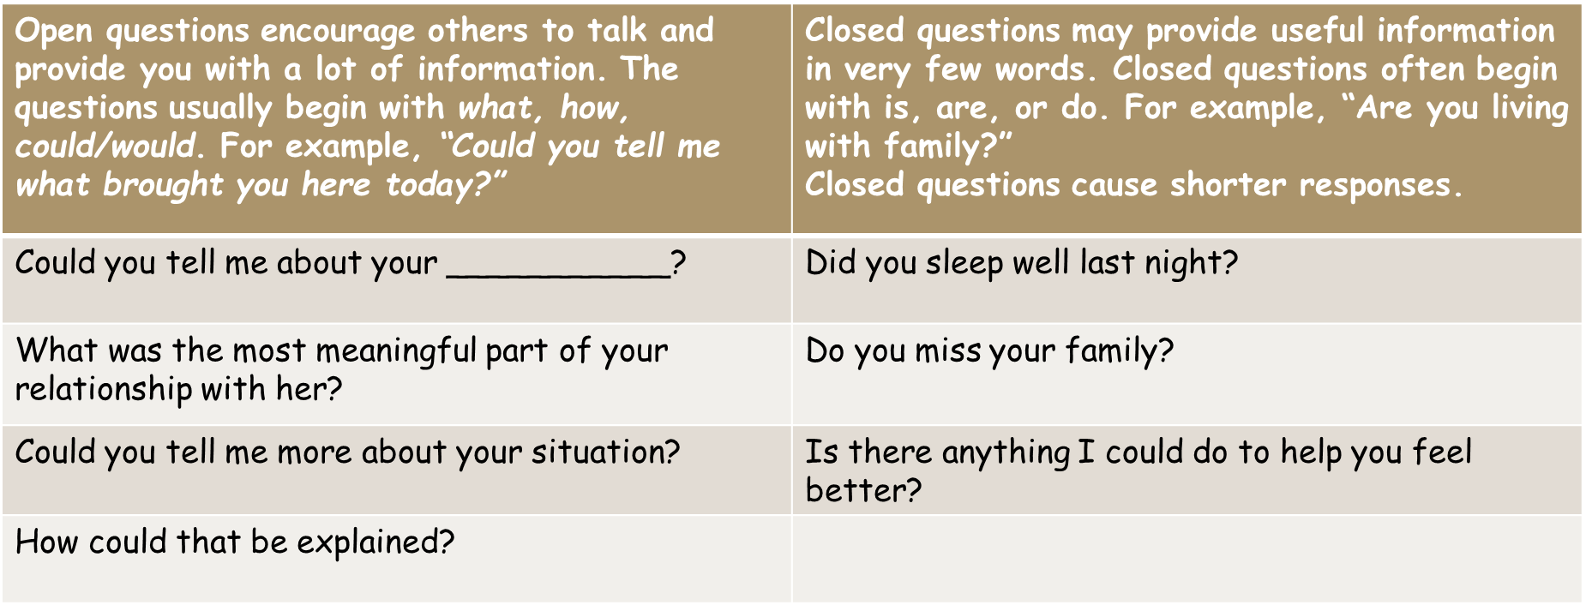

The Basic Listening Sequence (BLS)
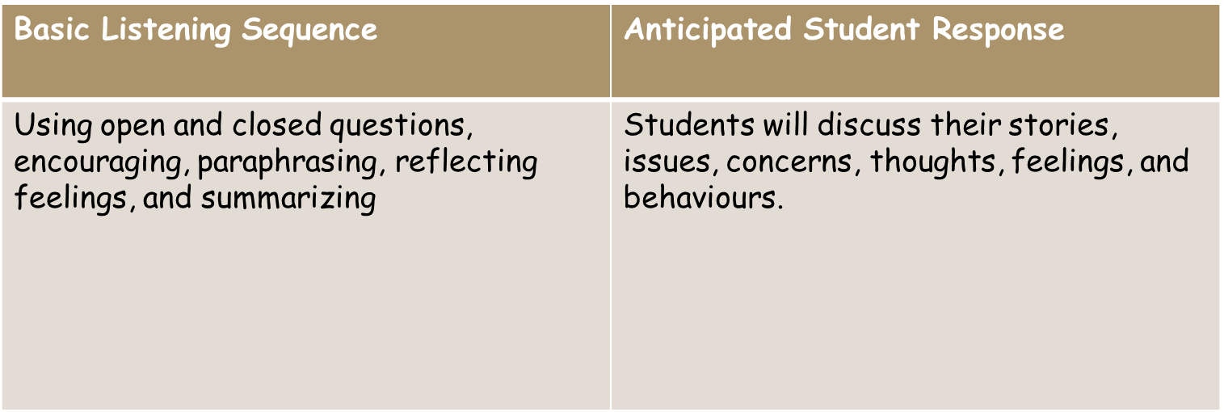
Encouraging, Paraphrasing, and Summarizing
The active listening skills of encouraging, paraphrasing and summarizing are the cognitive center of the basic listening sequence and are key in building the empathic relationship. When teachers attend to students, their story is heard, they open up and become ready for change. This leads to more effective executive brain functioning which in turn improves cognitive understanding, organization issues, and decision making (Ivey et al. 2018).
Encouraging
- Encourage with short responses that help the student keep talking. The responses may be non-verbal (head nods and pleasant facial expressions) or verbal (repeating key words and short statements).

- This will encourage the student to elaborate on the topic, particularly when encouragers and restatements are used in a questioning, supportive voice. An example of a restatement is, “You had trouble getting along with others at your last school”. Repeat two or more words exactly as the student used (Ivey et al. 2018).

Paraphrasing
- Paraphrasing is the most important cognitive empathic listening skill. At first glance, it appears to be a simple skill, only slightly more complex than encouraging. Paraphrasing covers more of what the student said, usually in several sentences, by using key words and phrases while catching the cognitive essence of what the individual said. It clarifies the student’s story.
- If your paraphrase is accurate the student will let you know, “you’re right”, or “yes”.
- The goal of paraphrasing is to facilitate exploration and clarification of student issues (Ivey et al. 2018).

How do you paraphrase?

Observe students, hear their important words, and use them in your paraphrase as much as the student does. The main idea is to reflect concepts and views of the student’s world, not yours. An accurate paraphrase usually consists of 4 dimensions.

1) A sentence stem sometimes using the student’s name. Names help personalize the moment. Examples are: “Justin, I hear you saying…”, Aleah, sounds like…”, “Looks like the situation is…”

2) The key words used by the student to describe the situation or person. Include main cognitions, ideas, and exact words from the student.

3) The essence of what the student has said in a briefer and clearer form. Identify, clarify, and feed back the student’s lengthy talk into a more succinct and meaningful statements. The teacher must stay true to the student’s ideas but not repeating them exactly.

4) A checkout for accuracy. Here you ask the student for feedback on whether the paraphrase was correct.

Summarizing

Summarizing falls along the same continuum as the key word encourager, restatement and paraphrase, but often includes feelings and emotions as well. Summarizing encompasses a longer period of conversation than paraphrasing; at times it may cover an entire conversation or even issues discussed by the student over several conversations. The summary essentially puts together and organizes student conversation, therefore, supporting the brain’s executive functioning.
- Attention is given to the emotions and feelings as they are expressed by the student.

“3 V’s + B”
Focus on a strategy and identify it as a necessary part of the helping process. Build upon each strategy.
Knowledge of Awareness, and Attending Behaviour/Empathy Skills
To communicate that you are attending and listening to a student use the “3 V’s + B”
1. Visual/eye contact- Engage in eye contact while speaking to the individual. Respect cultural differences when it comes to eye contact. In many cases students may feel more comfortable standing or sitting side by side instead of across one another.
2. Vocal Qualities- Communicate with a warm vocal tone and speech rate to match the moment. Ideally setting a calm tone in any environment is important. It is especially important during an escalated or heightened emotional moment for a student. Think of numerous ways you could convey they message, “I am really interested in what you have to share or say”.
3. Verbal Tracking- Track the student’s story. Do not change the topic, instead stay with the student’s topic.
4. Body Language/Facial Expression- Be your authentic self because it is essential in building trust. It is important to face the individual and lean in to show interest. Use encouraging gestures, and it is critical to show warmth. It is encouraged to practice by looking in the mirror and using your reflection to gauge the level of warmth and understanding that you convey through facial expression.
Ensure that your students know that you are available to talk throughout the day and set aside a certain time of the day, so they know you are accessible to them for a conversation. Often students will plan or think about approaching an educator if they know there is an opportunity.
- Attend to the narratives of your students. Look for themes in their stories to fully understand and empathize with their concerns. Focus on building rapport with them.

- Perhaps you may wish to approach a student during the time you set aside. Conversation starters to address a specific situation could be based on an observation you made.

- After greeting the student, remember to use positive vocal qualities when using observation as a conversation starter:
Examples (always greet first):
“I notice that you are alone at break time and seem to choose this specific spot to be by yourself. Is there a reason that you choose this spot during every break?”
“This morning I noticed that you walked into class and forcefully threw your bag on the floor. Then you kicked your desk and sat down. At the time you didn’t want to talk about it, but now it’s just the two of us. Could you tell me more about how your morning was before you came to school?”
“I notice that you have coming to class on time and smiling a lot more. How have things been at home since we talked last week?”
The walking and talking method- Many students who have a difficult time expressing their emotions, thoughts and behaviors may struggle even more if they are confronted about while sitting or standing in one spot. Ask the student if they would like to “walk and talk”. This often helps the individual become more open and willing to talk. Start walking and you may notice that the individual will begin to take the lead on the direction of the walk, let them. This gives them a sense of control and it allows for moments of silence to take place.
Empathy | Anticipated Student Response
Experiencing the student’s world and story as if you were that student, understanding their individual issues and saying back to them accurately, without adding your own thoughts, feelings, or meanings. This requires attending and observation skills plus using the important key words of the student but distilling and shortening the main ideas. | Students will feel that their issues are being understood. More classroom engagement may be explored by the student. The student’s reaction to empathy may lead the individual to a better self-understanding.
(Ivey et al. 2018)

Postmodern Approach in Supporting Students Through Trauma
This narrative approach operates by identifying the problems within social, cultural, political, and relational contexts rather than existing within individuals. They are very much concerned with considering the specifications of gender, ethnicity, race, differently abled, sexual orientation, social class, spirituality and religion as therapeutic issues. The approach is relational and anti-individualistic practice. This means that the there is more concentration on problem stories that dominate and subjugate at the personal, social, and cultural levels. The sociopolitical conceptualization of problems sheds light on those cultural notions and practices that produce dominant and oppressive narratives. People are able to come to an understanding of how oppressive social practices have affected them. This awareness can lead to a new perspective on dominant themes of oppression that has been such an integral part of a client’s story, and with this cultural awareness new stories can be generated (Corey, 2017)
Questions to ask to Gain a Better Understanding of the Multicultural Influences of a Student
What can you share with me about your background that will enable me to understand you more fully?
What challenges have you faced growing up in your culture?
How have you been able to draw strengths from your culture?
How can you draw from your culture during times of need?
Tell me more about the influence that your culture has played in your life.

Karpman Drama Triangle
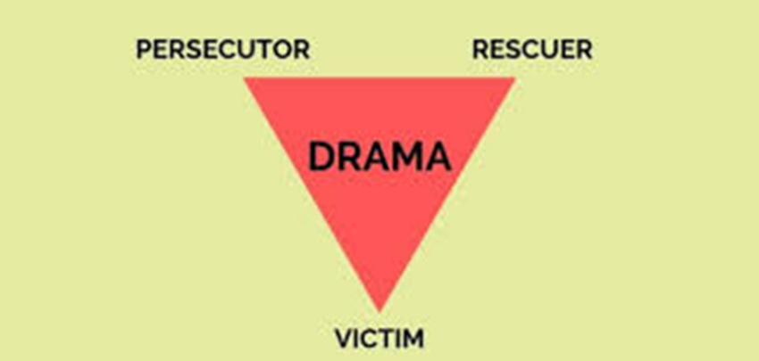
- Each of the drama triangle roles entails a discount.
- Persecutor discounts the value and dignity of others. Extreme persecutors may discount other people’s right to life, emotional, spiritual, and physical health.
- The rescuer discounts others abilities to think for themselves, and act on their own initiative.
- A victim discounts oneself.
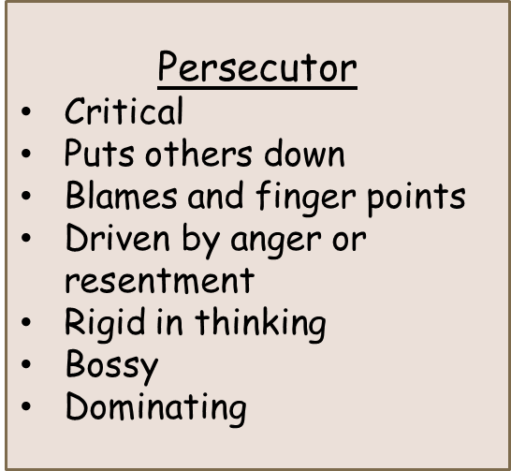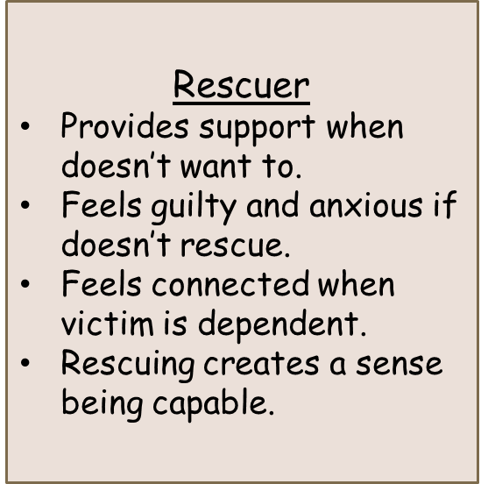

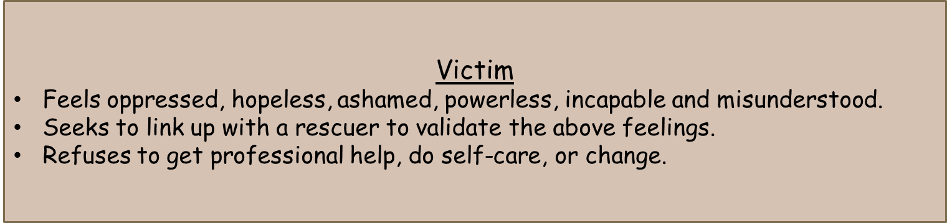
Karpman Triangle Self-Reflection Questions
Have been a rescuer, victim, or persecutor?
You might have been in all three at the same time. Could you think of a situation where one might play all 3 roles at once?
Have I agreed to do more than I want to do?
Am I doing more than half the work?
What boundaries do I need to set up?
Why do those boundaries need to be set up?
Am I owning my power in a positive and appropriate way?
Am I taking responsibility for myself and my actions?
What am I feeling about the situation?
How would I like to feel about the situation?
What action do I need to take to make sure that I deal with this in the best way possible so that it has the best outcome?
The_drama_triangle.pdf

How will teaching the Karpman concept to students that have experienced trauma allows them to gain more control of their situations?
- Students learn to be aware of the power of their own thoughts. This concept would work in classrooms from Grades 6-12.
- Frequent reminders and visuals in the classroom will reinforce the concept.
- To adapt the concept, a teacher might focus on one role for a student. For example, a student that continuously sees themselves as a victim might focus only on the role of the “victim” with the goal of taking responsibility for their actions/behaviours instead of placing blame on others.
Effective Practice for Teachers and Indigenizing Trauma Informed Responsiveness
A trauma informed teacher will adapt lessons and teaching style based on gauging of the trauma level in the classroom. The next step is to develop the plan for trauma responsiveness in the classroom.
“Children’s reactive behaviours from trauma can often be misdiagnosed as symptoms of attention deficit hyperactivity disorder (ADHD). That is because children and youth who are dealing with trauma may be impulsive, angry, or display other intense emotional behaviour. This is common with trauma. These children struggle with regulating behaviours and emotions, consequently a lot of children and youth then find themselves in trouble in school” (Wallace & Lewis, 2020).

- Use postmodern approach to ensure that there is more concentration on problem stories that dominate and subjugate at the personal, social, and indigenization levels.
- Teach the history of Indigenous people (varies depending on the location of school).
- Teach the impact of cycles and intergenerational trauma.
- Acknowledge how the cycles impact each generation.
- Speak about the importance of being aware of how traumas impact communities, families, and systems.
- Address the importance of breaking cycles.
- Have students focus on one cycle that they wish to end in their family (art lessons, journaling).
- Deconstruct the Indian Act and amendments made to the Indian Act.
- Explain how the Indian Act is still in place today and the impact on Indigenous peoples.
- Teach about shame, loss of language, family connections, but also teach about how the history of Indigenous people is empowering (postmodern approach).

- Empowerment through identity and uniqueness of the student.
- Conveying the message that you are willing to hold space for them which allows vulnerability.
- Accessibility to smudge (daily and as requested or needed).
- Songs- Learning the meaning behind the words of the songs.

Personal Characteristics of Effective Educators in Supporting Students Through Trauma
*Please do not take the “all or nothing” approach with the characteristics
Adapted from Theory and Practice of Counselling and Psychotherapy by Gerald Corey, 2018
Effective Educators are Open to Change:
1) Exhibit a willingness to make decisions about changing teaching style, space, and strategies to become a better support.
2) Adapting the space (quiet morning options for students e.g.: quiet space with sand timer options with boundaries and structure for adapted space).
3) Collaborates with others to create and work toward consensual goals (long-term and short-term).
Effective Educators are:
1) Sincere, authentic, and honest
2) “They do not hide behind the rigid roles”- Corey, 2018
3) Willing to acknowledge the mistakes they make and do not gently dismiss their errors, and do not dwell on it in misery.
4) Open to acknowledge mistakes and move forward in a better way.

Effective Educators in Supporting Students Through Trauma:
1) Appreciate and respect the diversity of traditions and cultures. They are sensitive to the uniqueness and influences of race, culture, class, sexual orientation, social class, and gender.
2) Base their support style from valuing students.
3) Being a teacher that respects uniqueness.
4) Cares about learning the reasons behind the behaviours.
5) Being a support person that is trusted by students (it takes time and effort).

What is Cognitive Behavioural Theory?
CTRI Crisis & Trauma Resource Institute
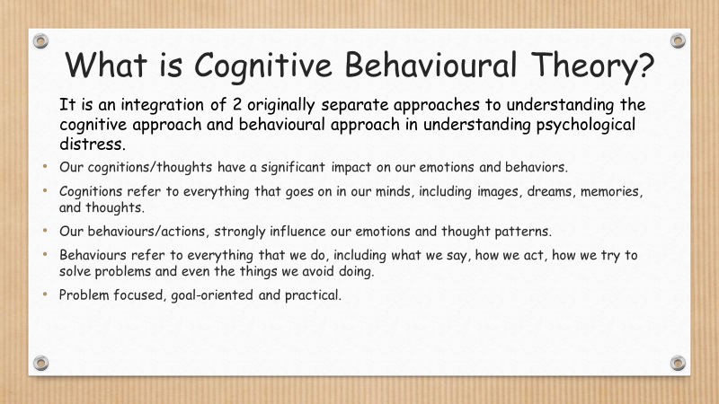
It is an integration of 2 originally separate approaches to understanding the cognitive approach and behavioural approach in understanding psychological distress.
- Our cognitions/thoughts have a significant impact on our emotions and behaviors.
- Cognitions refer to everything that goes on in our minds, including images, dreams, memories, and thoughts.
- Our behaviours/actions strongly influence our emotions and thought patterns.
- Behaviours refer to everything that we do, including what we say, how we act, how we try to solve problems and even the things we avoid doing.
- Problem focused, goal-oriented and practical.
- Identifying thoughts, beliefs and meanings that are activated when you feel emotionally distressed.
Techniques & Methods Cognitive Behaviour Approaches:
- Disputing irrational beliefs lead to emotional disturbances and self-defeat.
- Changing one’s language.
- Student learns to reframe thoughts to constructive thinking.
- Imagery- Mental practice which allows new healthy patterns to take the place of disruptive emotional patterns.
- Role Playing
Generally, positive events lead to positive emotions and negative events lead to negative emotions. It is important to not that recognize that meanings that we attach to a negative event may not be accurate, realistic, or helpful.

Examples of how different people may respond to construction on their way to work in the morning:
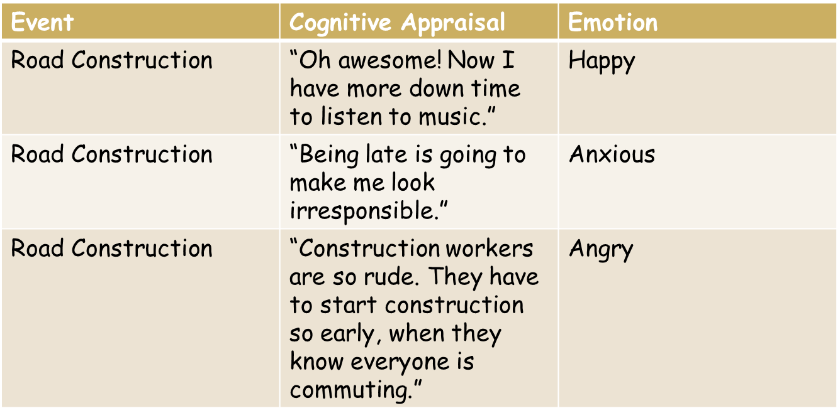
It is not the event that affects the emotions and behaviour, it is how the event is perceived.
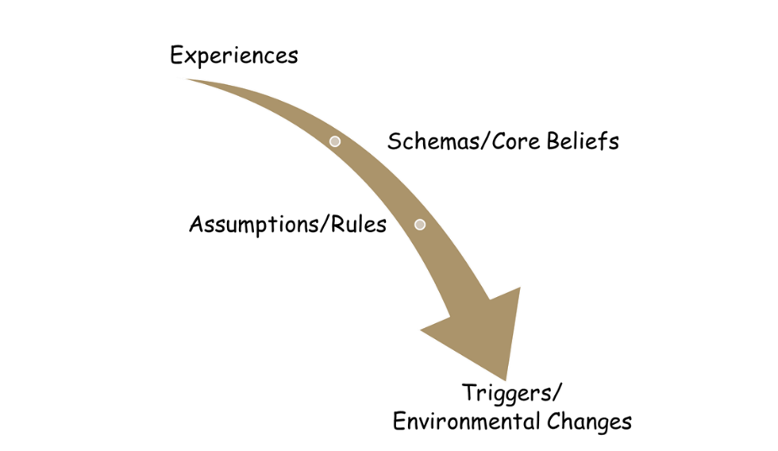
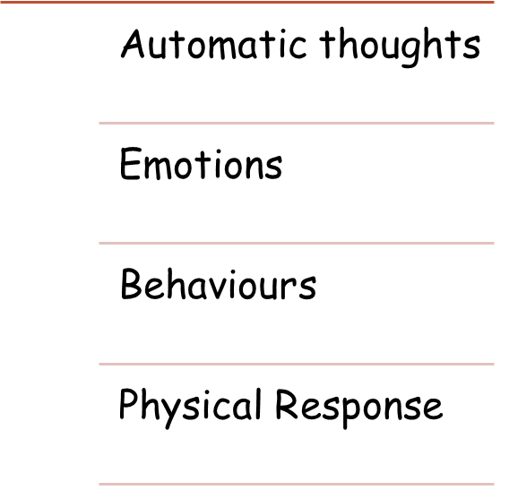

Cognitive Distortions
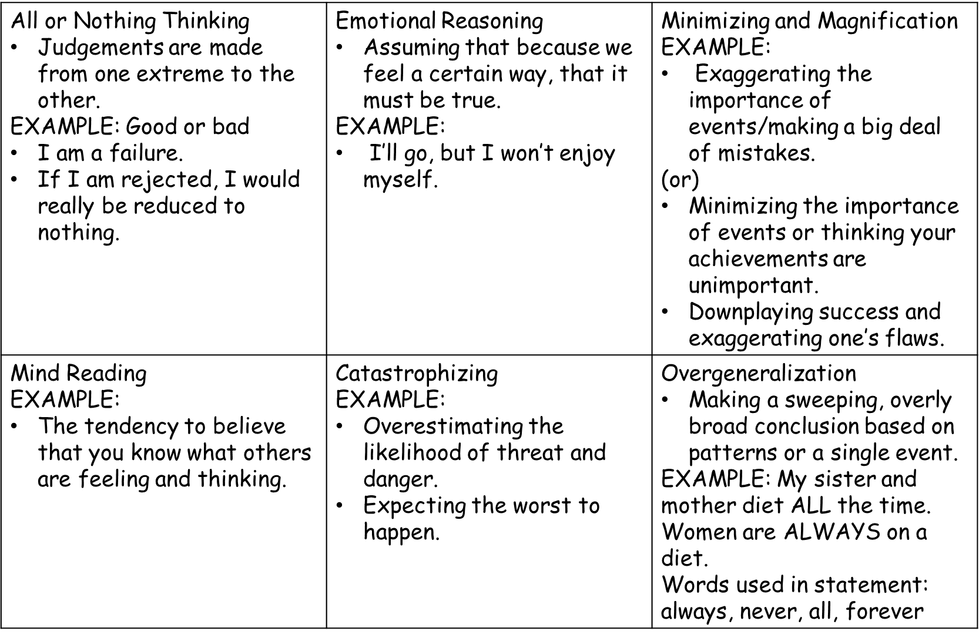
Cognitive Distortions: (from CTRI Crisis & Trauma Resource Institute)
1) All or Nothing Thinking- Involves the tendency to make judgements about oneself, personal or others that are placed in one of two extreme categories (good or bad; total failure or total success).
2) Magnification or Minimization: Includes either an exaggeration or minimization of the significance of an attribute, event, or sensation.
3) Overgeneralization- A conclusion is made about a single or isolated event and then extended illogically to one’s broader beliefs about oneself, others or the world (an individual uses words like always and never).
4) Emotional Reasoning- One believes that reality is determined by one’s feelings. This is a highly individualized form of construing reality as the emotional reaction leads to a conclusion that something is true, regardless of the evidence.
5) Personalization or Depersonalization- Personalization is the tendency to relate external events to oneself when there is little or no evidence for doing so. Excessive responsibility or blame is taken for negative events. Depersonalization occurs when one believes in their inability to effect change or to influence a situation.
6) Should or Ought to- Thinking about oneself, others of the world in terms of should, must, or ought.
7) Mind Reading or Predicting the Future- The tendency to believe that one knows what other people are thinking or feeling, or why they are acting the way they do, without any clear evidence. One believes they are able to determine how people are feeling toward themselves. One believes they could predict the future outcomes based on how they think people feel.
8) Mental Filter- One negative aspect of a situation is examined to the exclusion of the larger positive aspect, which overshadows one’s entire perspective.
9) Catastrophizing- One overestimates the likelihood and intensity of threat and danger, which causes one to expect the worst-case scenario.
10) Labelling- The tendency to attach general labels to oneself or others rather than describing actions or events.
By identifying the thinking styles that we use, we could identify whether the thinking patterns we use are helpful or accurate, or false and unhealthy. Keeping a record of unhealthy or unhelpful thoughts can assist you to identify which situations lead to negative thinking. Recognize the feelings that go along with them, and work on finding a more balanced way to think about others, yourself, and situations.
Situation  What led to the thoughts? | Cognitive Distortion  What thoughts or images went through your mind? | Emotions  What emotions did you feel?

Downward Arrow Technique
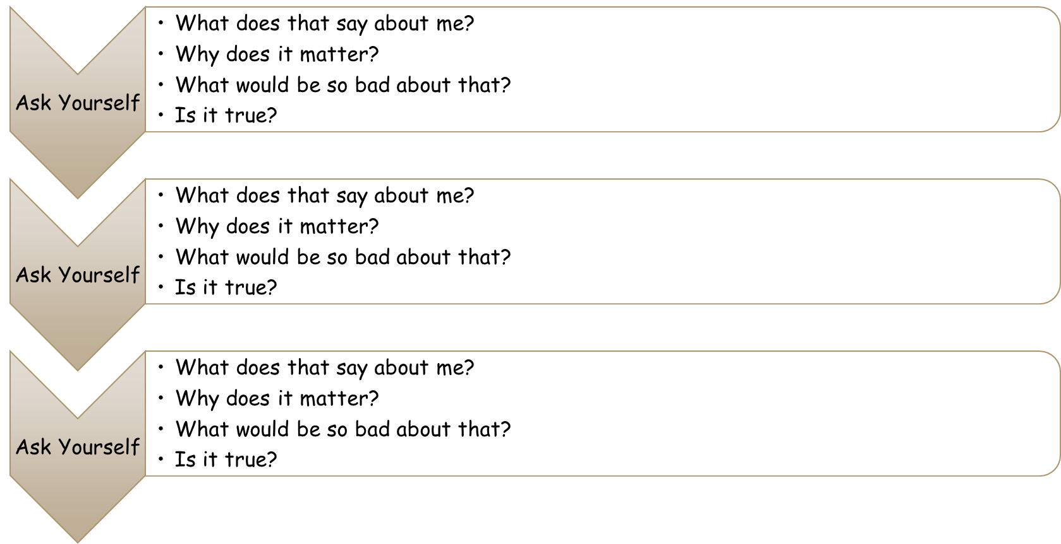
For example, a student shares that he does not think that he made the hockey team. Tryouts were last night.
Jason: I’m sure I didn’t make it on the team.
Teacher: Ok, what would be so bad about that?
Jason: This was my only plan for winter. I don’t know what else I would do.
Teacher: So, what would be so bad about not knowing what else to do?
Jason: I would totally waste the season. I wouldn’t be able to do anything fun with my friends.
Teacher: Ok, so what would be so bad about having that kind of season?
Jason: I would feel like such a loser. All my friends will be on the team.
Teacher: What would be so bad about feeling like a loser?
Jason: It would mean that I am not a good enough hockey player to be on the team.
Teacher: Is that true? Where did the thought that you are not a good hockey player come from?
*Jason will reflect on where this thought came from (the source). Use the Basic Listening Sequence (BLS) to support Ja in gaining a better understanding of where his distorted thought stemmed from.
Thought Challenging: Helps the student consider things from a more objective perspective, rather than just assuming that the thoughts are facts or “truth” (even though some thoughts really feel like they are facts).
- Recognize the negative or distorted thought.
- Ask probing questions
- What is the evidence for this thought?
- What is evidence against the thought?
- Am I basing the thought on facts, or on feelings?
- Is this thought black and white when reality is more complicated?
- Could I be misinterpreting evidence?
- Am I making an assumption?
- Replace the negative thought with something rational
- Release your judgement

Cognitive Behaviour Theory Approaches with Children
- Commonly used to assist children with worries, low mood, and anger.
- Self-Regulation- Blue Zone, Yellow Zone, Green Zone, Red Zone
- Self-Regulation- Getting students to recognize when they are in a specific zone and displaying unexpected behaviours.
- Self-Regulation- Getting students to recognize strategies to regulate themselves into a more comfortable state by using zone of regulation tools such as deep breathing, going for a body break, brain break, or implementing music/art into numerous subject areas.
- Guiding self-statements - “Stop, Think, Act”.
- Behaviour based performance exercises (social skills and problem-solving training).
- Verbal Prompts- “What are my options to solve this problem?”
- Recognition of thought distortions.
- Modelling, role play, and reinforcement.

How to Respond to a Student in Crisis. Examples and Non-Examples
Examples | Non-Examples
- Hold space by using BLS, attending and empathy behaviour.  - Remain calm and reassure the student that they are in a safe space.  - Inform them of what the next step is.  - Remind student to focus on acknowledging their feelings, being with their feelings and having compassion for their feelings (ABC Method)  - Document it, inform principal, reach out to appropriate service providers, create a plan for the day to ensure students is safe, work on carrying out the plan for the days to come.  - Understand that student safety plans change frequently to adapt to the needs of the student.  - Ensure that school team/care team are a part of the plan and know their roles.  - Respect the student’s confidentiality when informing the principal of the situation (closed door conversation). | - Non-verbal cues that show disinterest, disgust, fear, or exaggeration.  - Tone of voice is condescending or giving the impressions of negative judgement.  - Saying you don’t have time right now. Instead say, “I need to get _____ to take over supervision of the class so we could talk. Are you okay with waiting a few minutes while I do that?  - Do not draw attention to the student.  - Do not announce that your speaking privately to the student.

Strategies for Engaging with Families Regarding Student Trauma/Family Trauma
- Have some time to yourself prior to the meeting to focus on your energy and ensuring you are calm and approachable for the family.
- To start the conversation, speak about a positive quality of the student.
- Understand your role and purpose in the meeting, clarify that with the family. Examples may include noticing self-harm behaviour of the student, student self-disclosure of issues at home, anxiety in the classroom, student depression, aggressive behaviour in the classroom, or behaviour related to a traumatic event, loss, or grief.
- Understand that the topics most likely will be triggering to the family. Be gentle with your approach to discussing this.
- Let the family know that you are a main support in the school setting for their child. This will give them comfort in knowing that their child has a safe space and an empathetic teacher.
- Understand that in most cases, the tension is high, and the family often feels misunderstood, judged, or angry due to past events.
- Use factual statements, not assumptions. Example instead of saying, “There is something that is causing Clara to self-harm, is there anything happening at home?”
SAY, “I have noticed that Clara has multiple cuts on her forearm.” Then say, “I spoke with Clara about it and she said that she does self-harm. I would like to ensure that Clara has support in a school setting to address this in a therapeutic way.”
- Understand that there may be aggression from family, especially if they are already aware of their child’s state/actions/behaviour and do not have the skills to address it, or they wish to carry on as though nothing is wrong.
- What to do when there is aggression during a family meeting- Be calm, do not respond in the same demeanor or tone that is presented to you. Be ultra-professional.
- Use observation statements to de-escalate the situation: “I notice that when I mentioned Clara’s marks on her arm, you became very upset by that. That is not my intention to upset you.” Usually, the parent will feel understood and agree then state why they are upset.

Addressing Situations or Confronting a Student with the use of Observation Statements to Promote a Solutions
- Use direct observations of behaviour/actions- “I notice that you display aggressive behaviours toward the end of the day. An example is, yesterday before dismissal, you seemed agitated and left the class. You slammed the door on your way out. Today, you are displaying agitation and aggression by pushing another student and it is nearly time to go home.”
- By using observations without judgement or assumption, this allows the student to become more open to talking about the thoughts and feelings behind the behaviour.
- Empathic confrontation- a supportive challenge in which you note the discrepancies and the feedback or paraphrase those discrepancies to the student. Use appropriate attention to underlying emotional issues.
- Using empathic confrontation in a model sentence- “On one hand you mentioned that you like school, but on the other hand you do things that are aggressive in school, and spend the late afternoons agitated or upset. Could you tell me more about why that happens?”
Helping students cope:
1) Listen empathically and search for internal and external conflict and contradictions in the student’s stories.
2) Validate their cognitions and emotions around incident(s).
3) Build resilience by focusing on internal strengths as well as external resources that provide strength and support to cope with challenges.
4) Explore and reframe the contradictions in the situation as appropriate.
5) Facilitate an action plan for the next steps toward working on the specific behaviours.

Interpersonal Influencing Skills for Change
Allen E. Ivey/Mary Bradford Ivey/Carlos P. Zalquett
Reflection of meaning and interpretation/reframe: Helping Students Restory their lives/situations.
- For many of your students this may be the most helpful influencing skill for finding meaning and vision in life, as it provides goals that support them through difficulties.
- Establish goals, values, and a sense of life vision.
- Students address self-reflection questions, such as Who am I? What sense does anything make? How much control do I have over my life?
Reflection of meaning: Helping others find deeper understanding of significant basic issues, such as life vision and purpose, underlying their thoughts, feelings, and behaviour. In turn, finding a deeper meaning leads to a new interpretation of life.

Interpretation/reframing: Seeks to provide a new way of understanding their thoughts, feelings, and behaviours, and often this also results in perspectives on making meaning. Interpretation often comes from a specific theoretical perspective, such as decisional, or multicultural. Students generate their own meanings, whereas reframes usually come from the interviewer/teacher/person guiding the conversation.

“Meaning” as the core of student experience and its relationship to feelings, thoughts and behaviours. Meaning can drive action.
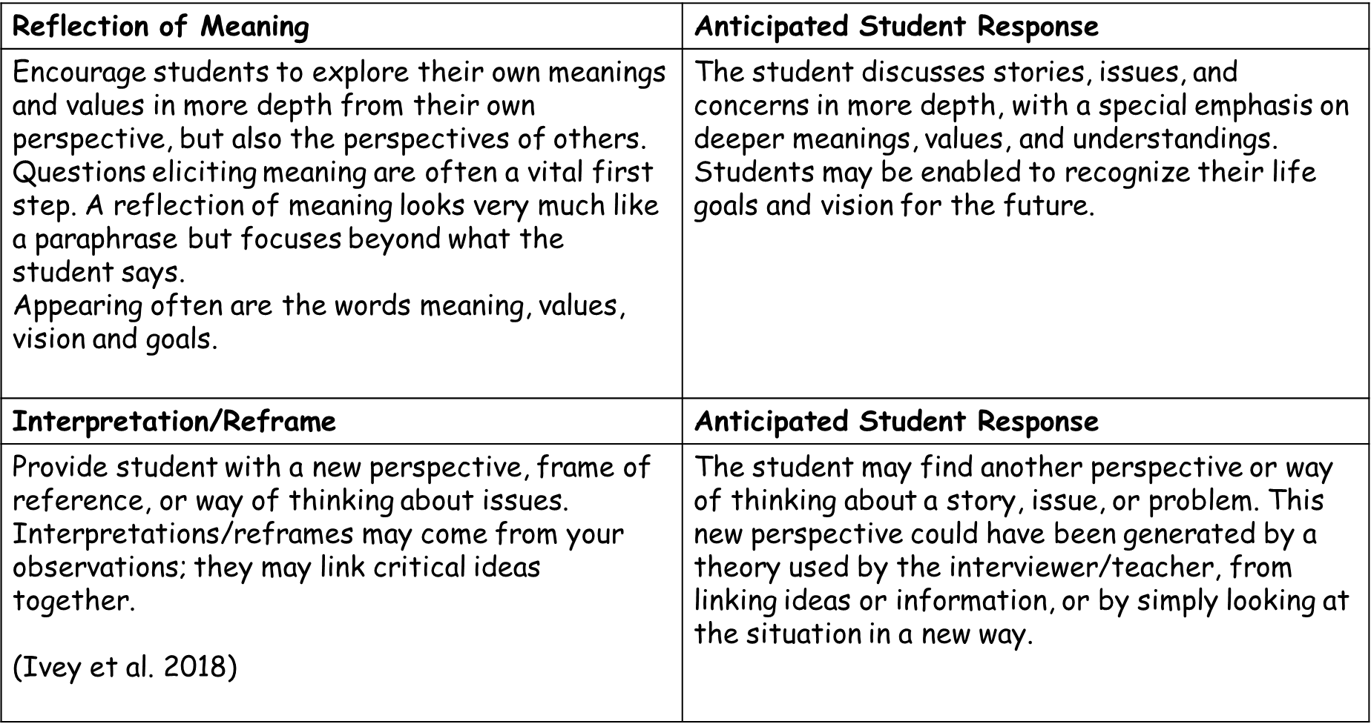

Elicit meaning: Asking the student a variation of the basic question, “What does_________ mean to you?” At the same time effective exploration of meaning becomes a major strategy in which you bring out the student’s stories. You use all listening, focusing, and confrontation skills to facilitate this self-examination, yet the focus remains on the meaning and finding purpose.
- Review of life goals and purpose leading toward a more meaningful life can result from this exploration.
Examples of a variation of basic questions:
What has given you the most satisfaction in ____________?
What has been missing for you in life (at the present moment)?
What do you value in life?
What is the purpose of your work ethic in class?
What things in the future will be most meaningful to you?
You have said you wonder ______________, could you share some of your thoughts about why you wonder about that?
What gift do you feel that you have to offer the world?
Elicit meaning often comes before reflection. Reflection of meaning involves student direction; the interpretation/reframes implies interviewer/teacher direction. In the reflection of meaning, the student provides the new and more comprehensive perspective, whereas an interpretation/reframe offers a new way of being as suggested by the interview/teacher.
Linking- is an important part of interpretation. In linking two or more ideas are brought together, providing the student with a new insight. The insight primarily comes from the student reflection of meaning, but almost all from the interviewer/teacher in interpretation /reframing.
“You can’t connect the dots looking forward; you can only connect them looking backward. So, you have to trust in something- your gut, destiny, life, karma, whatever. This approach will never let you down and it has made all the difference in my life.” -Steve Jobs
Questions Leading Toward Recognizing of Life’s Purpose and Meaning
- Looking back on your life, what have been some of the major satisfactions? Dissatisfactions?
- What have you done right?
- What have been peak moments and experiences of your life?
- What might you change if you were to face that situation again?
- Most of us have multiple emotions as we face major challenges such as this. What are some of these feelings, and what impact are they having on you?
- What are your life goals?
- What do you see as your mission in life?
- What does spirituality mean to you?

Eliciting meaning: “What does ____ mean to you?” Insert key important words of the student that will lead to meanings and important thoughts underlying key words. “What sense do you make of it?” “What values underlie your actions?” “Why is that important to you?”.
Reflecting meaning: Reflection of feeling except the words meaning, values, or intentions substitute for feeling words. For example, “You mean…,” “Could it mean that you…?” “Sounds like you value…,” or “One of the underlying reasons/intentions of your actions was…” Then use the student’s own words to describe their meaning system. You may add a paraphrase of the context and then close with a checkout. A checkout is making sure that students leaves the conversation in frame of mind where they feel heard or understood.

Interpretation/Reframe: The teacher/interviewer helps students gain a new perspective, new frames of reference, and sometimes new meanings, all of which can facilitate students’ changing their view and way of thinking about their issues. This skill comes primarily from the teacher’s observations and occasionally from the student.

References

Corey, G. (2017). Theory and Practice of Counselling and Psychotherapy (10th ed.). Belmont, CA: Brooks/Cole.
CPA. (Ed.). (2017, January). Canadian Code of Ethics for Psychologists. Retrieved July 16, 2020, from https://cpa.ca/docs/File/Ethics/CPA_Code_2017_4thEd.pdf
CTRI Crisis & Trauma Resource Institute. Retrieved August,21, 2020 from www.ctrinstitute.com
Ellis, A., & Ellis, D.J. (2011). Rational emotive behavior therapy. Washington, DC: American Psychological Association.
Ivey, A., Ivey, M. B., & Zalaquett, C. (2017). Intentional Interviewing and Counseling. Pacific Grove, CA: Cengage US.
Nakazawa, D. J. (2015). Childhood disrupted: How Your Biography Becomes Your Biology, and How You Can Heal. New York, NY: Atria Books.
Ortner, N. (2014). Tapping solution: A revolutionary system for stress-free living. Carlsbad, CA: Hay House.
Wallace, K. O. (2020). Trauma Informed Teaching Through Play Art Narrative. S.l.: Brill Sense.

