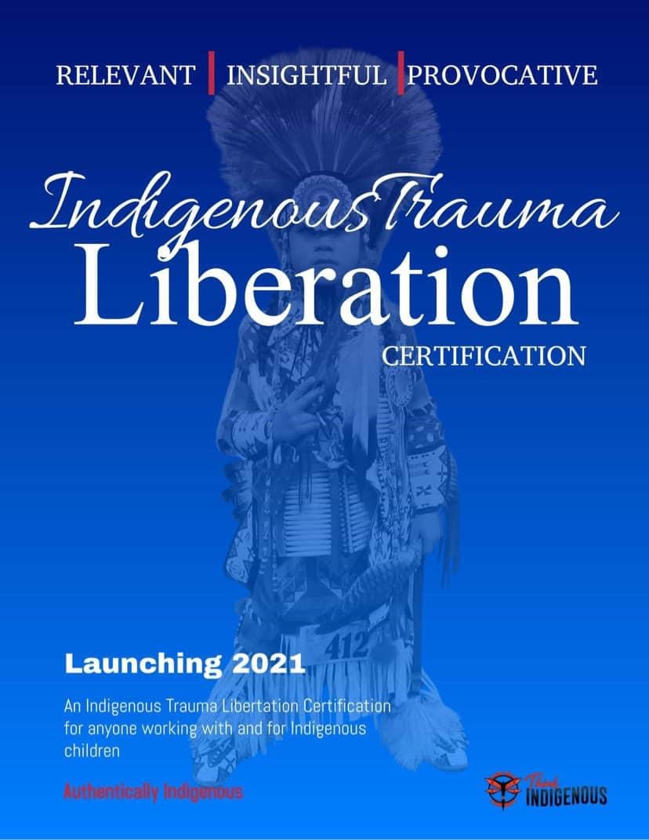

Hello!

I am so excited to be doing this ITLC certificate with you.

Here is a list of supplies you will need:

Day One:
Paper and tape(tape is optional)
Markers, pencil crayons, paint, crayons (pen if you have nothing)

Day Two
Rubber duck or any toy or anything that looks like a toy ie: painted rock etc.
Also you can use things in your home and around you as we go along.
But also markers, pencil crayons, paint or crayons (pen if you have nothing)

We are going to learn alot about trauma informed practice and how we can liberate students through our own indigneous ways of knowing, being and doing that has been around since time immemorial.

Can’t wait to meet you all!
Tatum Alert
BISW,MSW, BEd

